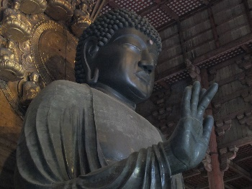
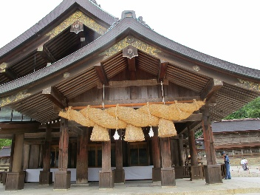
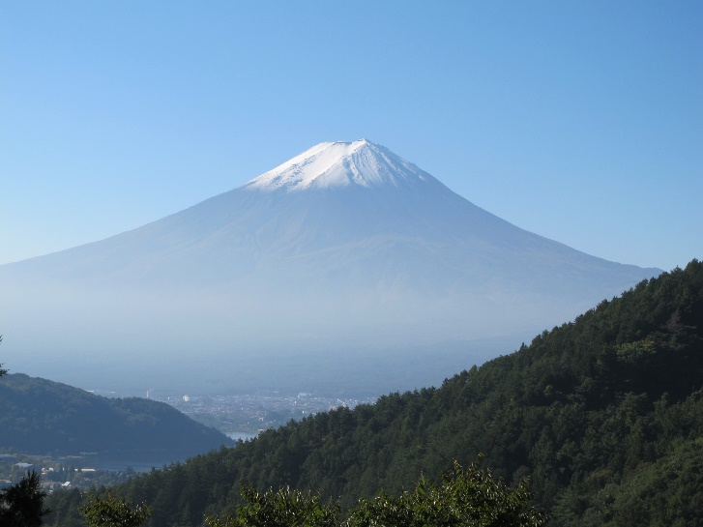
It is a precious treasure representing Japan.
Fuji, Izumo Taisha Shrine, and the Great Buddha of Nara. Please come and see them. We welcome you. JH7VCH （CQ ZONE:25 ITU ZONE:45）

